**New Streaming Portal**

URL : test.schoolhub.sg

Stream : Normal (A)

Username : 2X_02_24

Password : GG1234

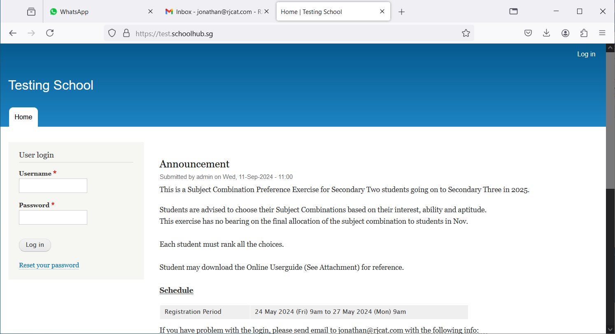

Enter username and password and Click Login

## Register Choices

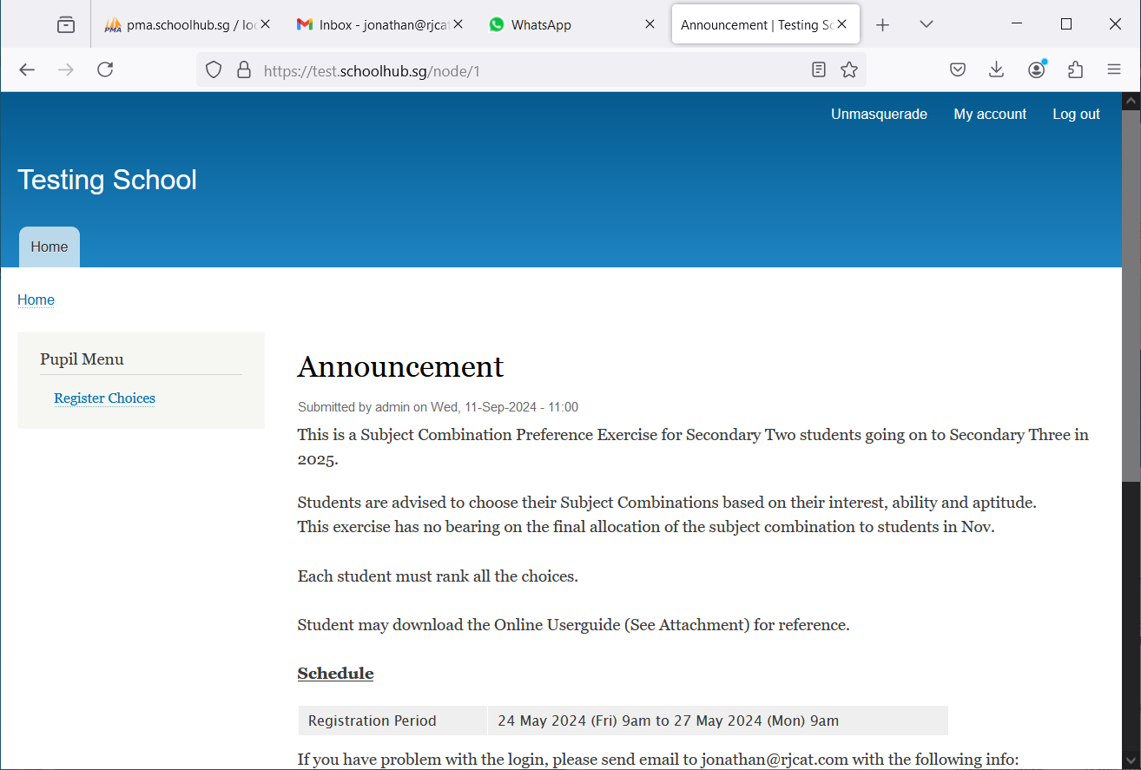

Click Register Choices to begin

## Register Choices

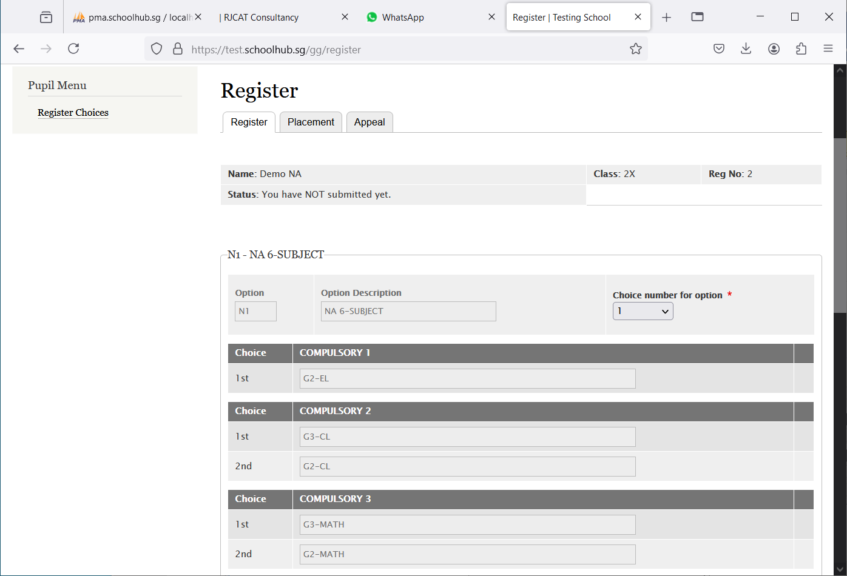

Hold and Drag

If you prefer to take the subject at a Less Demanding Level (LDL), you can drag and drop the choices.

If you are offer the subject at a More Demanding Level (MDL), you will see 2 choices. Default is MDL.

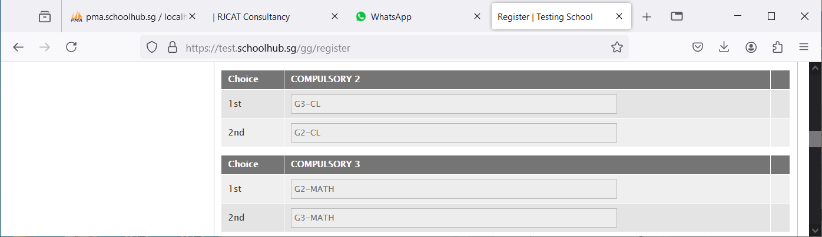

You prefer to stick to G2-MATH

Now G2-MATH is 1st and G3-MATH is 2nd

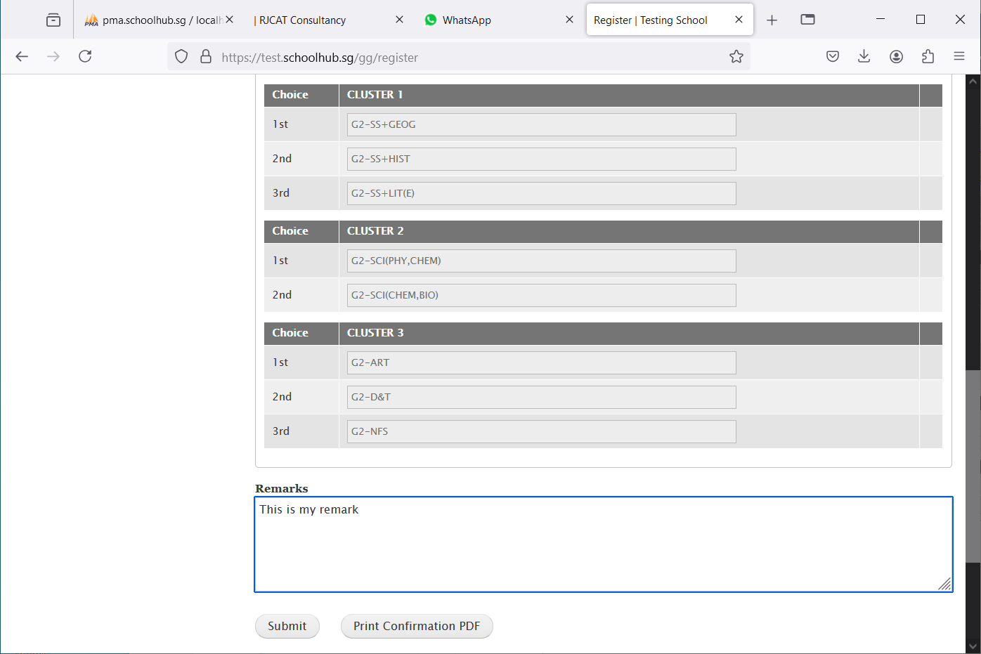

Enter any remark you wish to communicate with your teacher

Click Submit to save your choices. You may change them before the closing date.

Click Print Confirmation PDF to get a copy of the PDF for your reference.

## Sample Result Slip

