**New Streaming Portal**

URL : test.schoolhub.sg

Stream : EXPRESS

Username : 2X_03_24

Password : GG1234

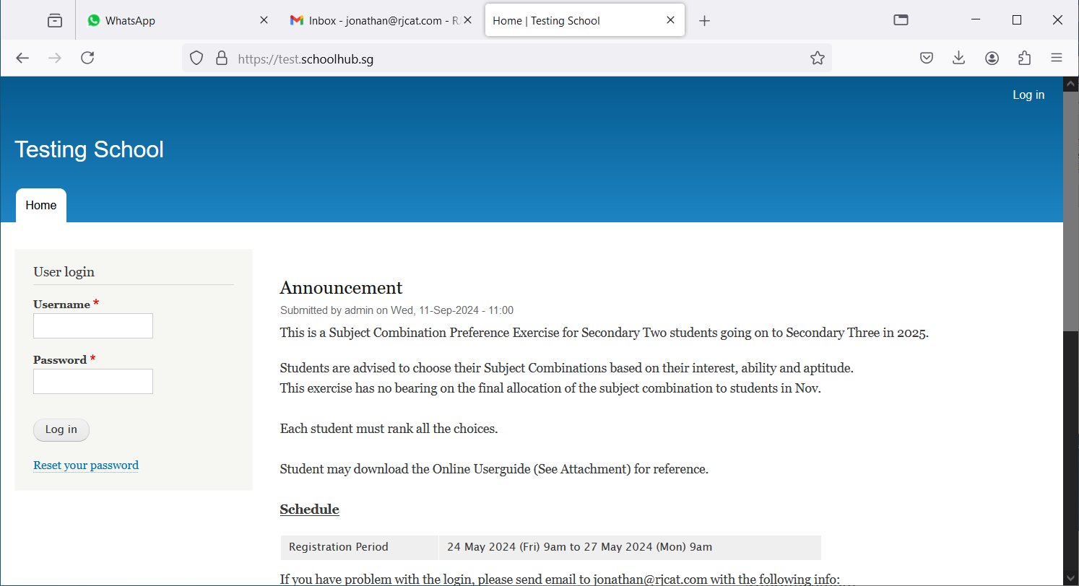

Enter username and password and Click Login

## Register Choices

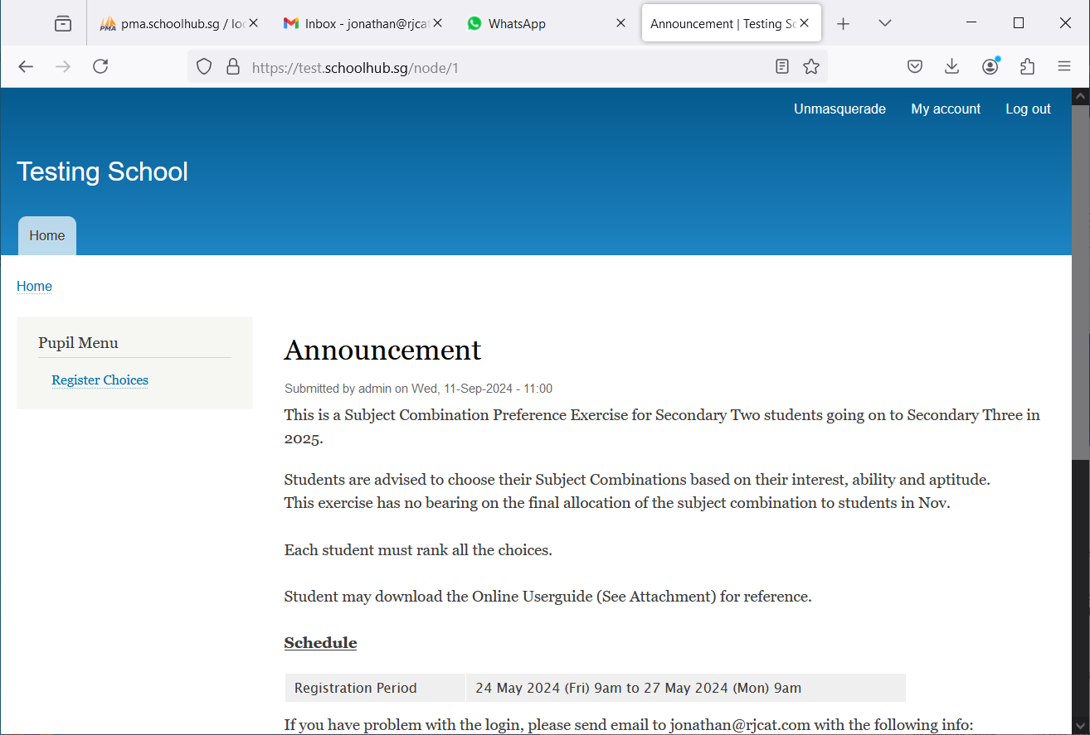

Click Register Choices to begin

## Register Choices

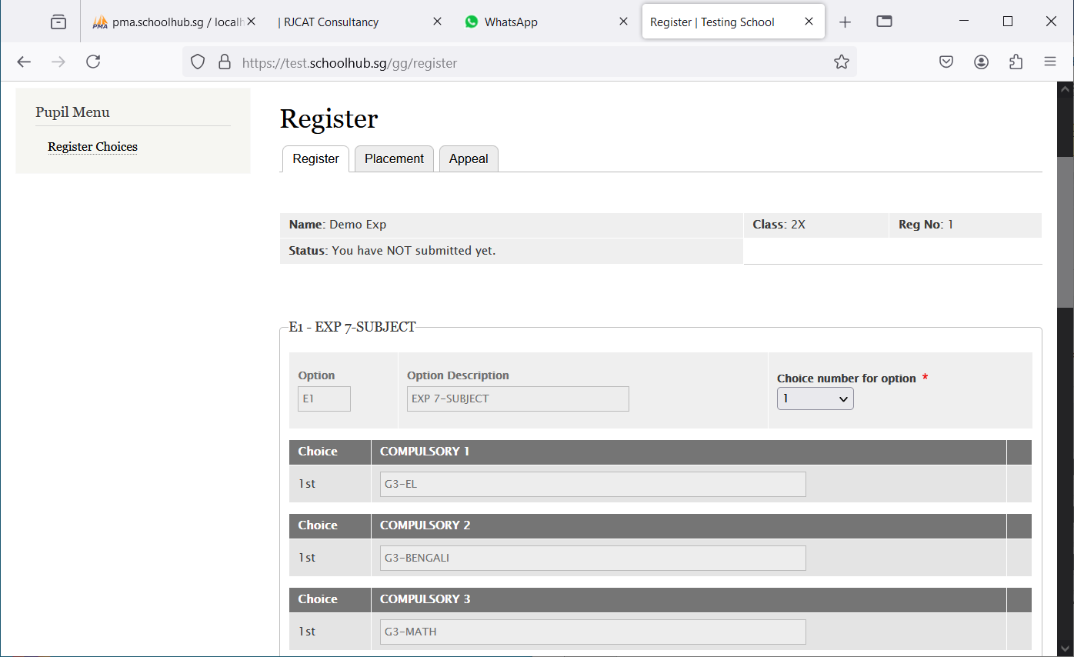

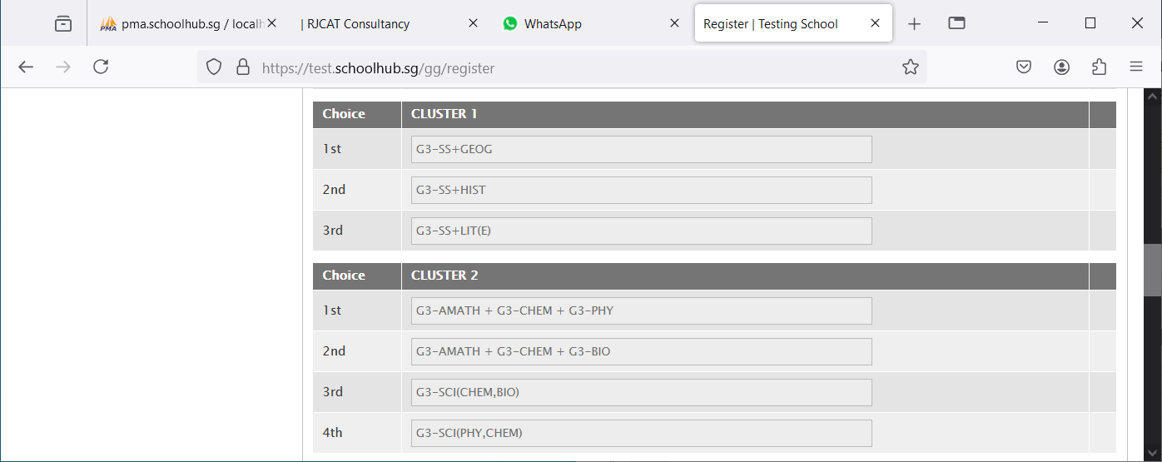

Hold and Drag to change your choices

1st Choice = G3-SS+HIST

2nd Choice = G3-SS+GEOG

3rd Choice = G3-SS+LIT(E)

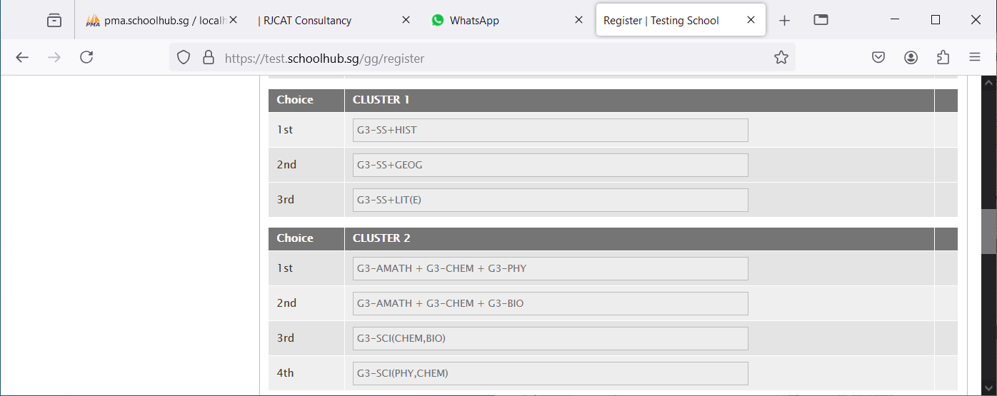

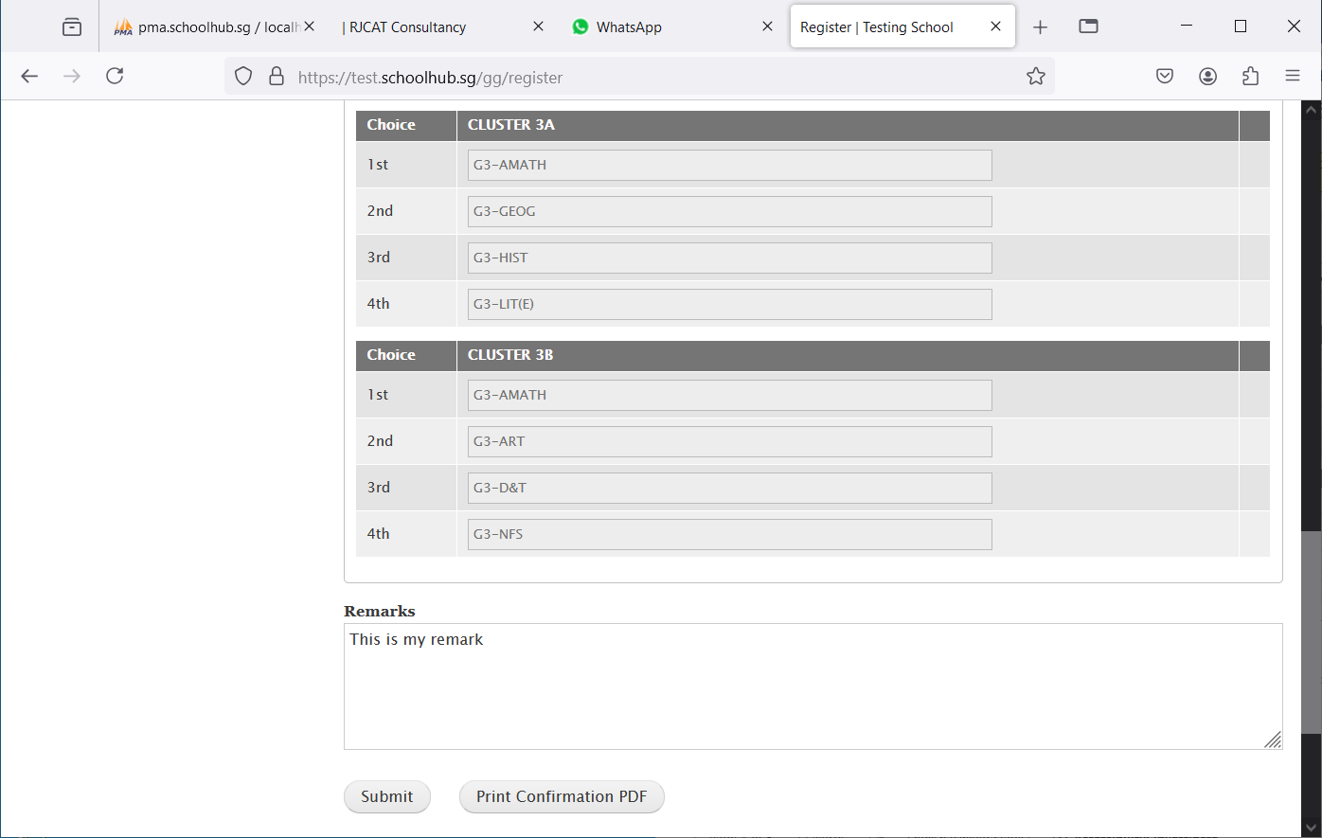

Enter any remark you wish to communicate with your teacher

Click Print Confirmation PDF to get a copy of the PDF for your reference.

Click Submit to save your choices. You may change them before the closing date.

## Sample Result Slip

